Work Instructions (WI) of NVR

Project Name: Bangladesh Railways

Project Number: P252405032

Contract Number: 4500010056

Document Number: P252405032 _Work_Instruction_BR_NVR_V1.00

Module Name: PAPIS & CCTV System

Edition: | Revision History: | Owner: | Reviewer: | Approver:
1.00 | Initial Release | Saurabh Tyagi 21.05.2026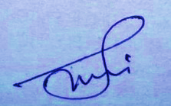 | Nitin Tyagi  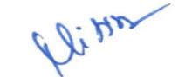  20.05.2026 | Rakesh Kumar Singh 22.05.2026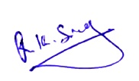

All information in this document is subject to change without notice. No part of this document may be reproduced or transmitted in any form or by any means, electronic or mechanical, for any purpose, without the express written permission of PPS.

Table of Contents
1. INTRODUCTION 3
1.1 PURPOSE 3
1.2 OBJECTIVES 3
2 REQUIRED TOOLS AND EQUIPMENT 4
3 CONSUMABLES 5
4 Safety Precautions 7
5 Follow 5S 8
6 Components Identification and visual Inspection 9
6.1 Component List: 9
6.2 Visual Inspection: 9
7 Steps for NVR Assembly 10
7.1 Fitment of all connectors 10
7.2 Harness and Connectors 11
7.3 ASSEMBLY OF POWER SUPPLY BOARD (12/24) 12
7.5 ASSEMBLY OF CADDY FRAME AND FITMENT 17
7.6 CABLES AND CONNECTORS 20
8 FITMENT 22
8.1 FITMENT OF SUPPLY BOARD (12/48) (33.92.1468) AND POWER SUPPLY (12/24) (33.92.1479) 22
8.2 FITMENT OF LED BOARD 23
8.3 FITMENT OF NVR BOARD 24
9 CONNECTION DETAILS 26
10 FINAL ASSEMBLY UNIT 31

INTRODUCTION

PURPOSE

The purpose of this document is to provide detailed, step-by-step guidance for assembly of the Network Video Recorder (NVR) system. To ensure consistent quality, providing structured training, supporting troubleshooting efforts, and maintaining safety and efficiency throughout the assembly process.

OBJECTIVES

To guide assembly personnel through the process, ensuring accuracy and consistency in assembly procedures. Assembly work instructions for a network video recorder aim to optimize the assembly process by ensuring accuracy, consistency, efficiency, and safety.

REQUIRED TOOLS AND EQUIPMENT

- Screw driver
- Aligner
- Wire stripper
- Nose Plier
- Hex Spanner
- Spanner
- Wire Cutter
- Soldering Station
- Crimping tool
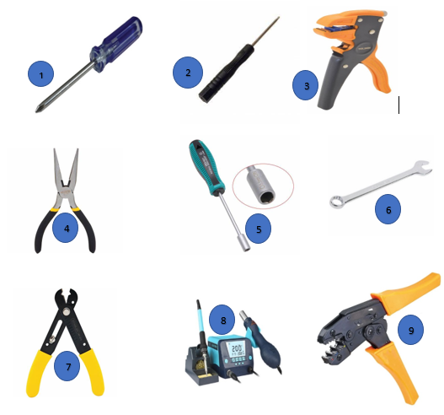

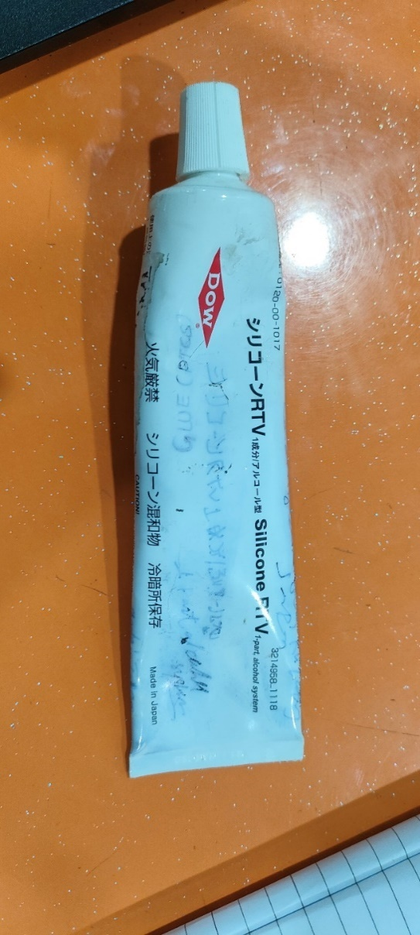
CONSUMABLES

1. Loctite 243 2. Silicon RTV
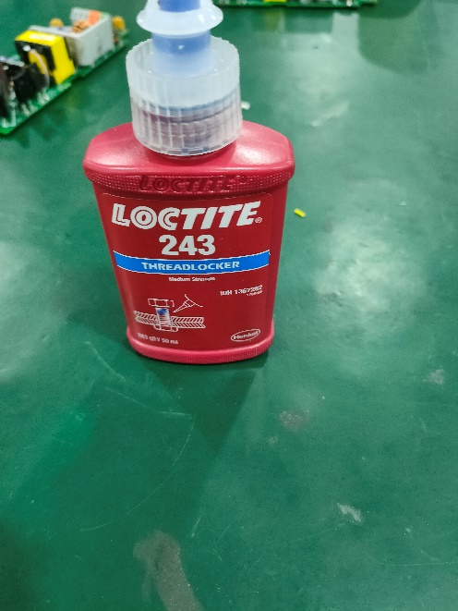

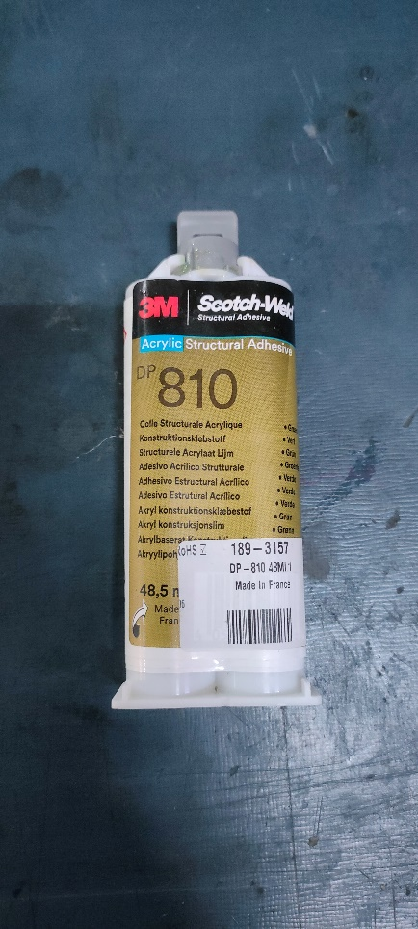
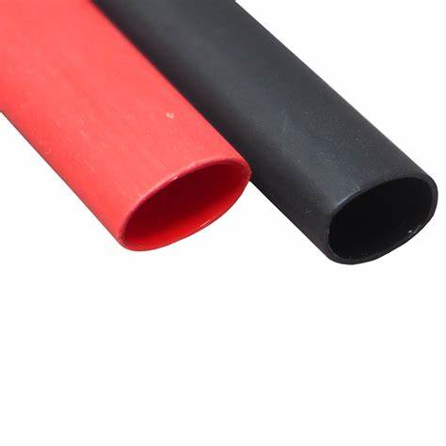
3. Sleeve 4. Glue (NS 810)

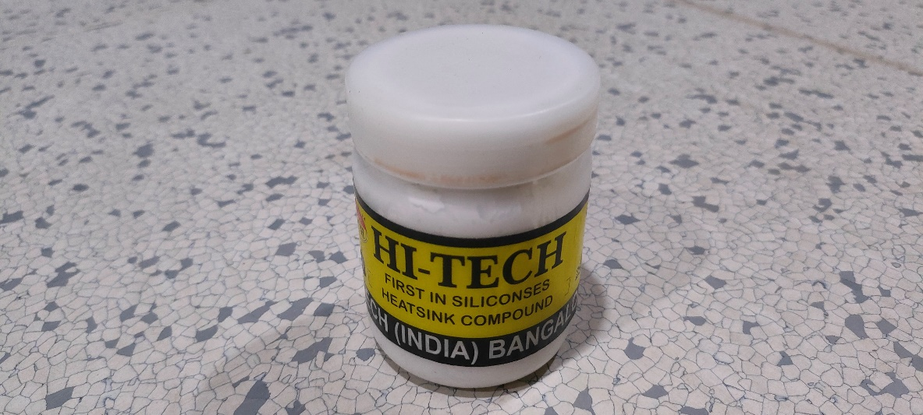
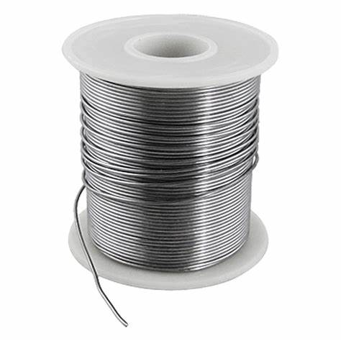
5. Soldering wire 6. Thermal cooling paste
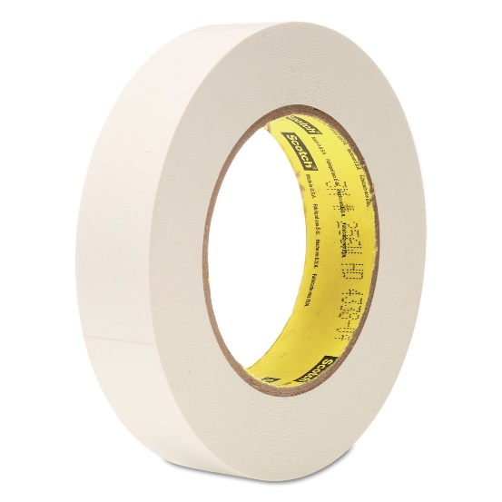
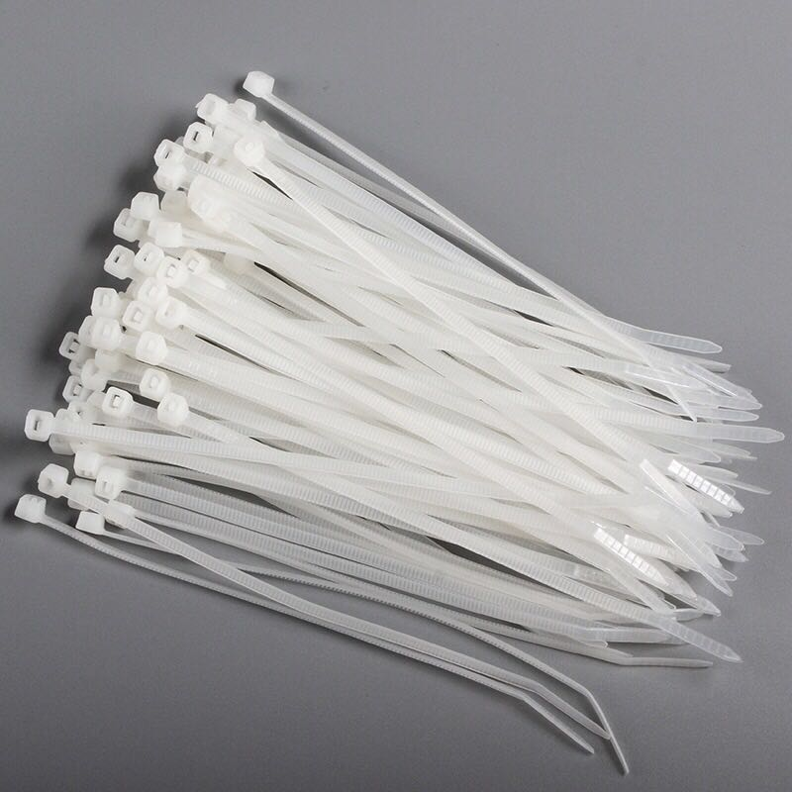
7. Cable tie 8. Paper Tape

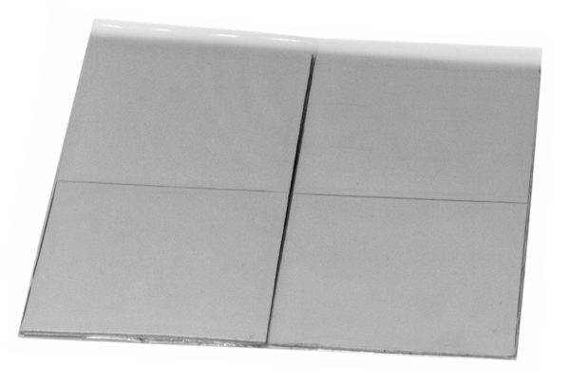
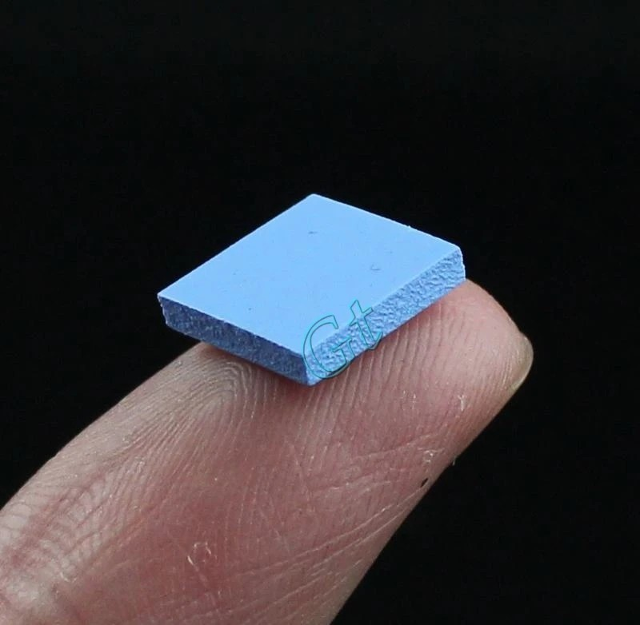
9. Thermal Pad

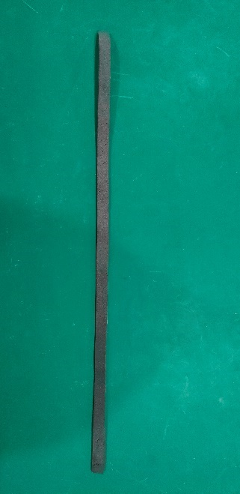
10. Gasket

Safety Precautions

Ensure the assembly area is clean, well-lit, and free from static electricity that could damage electronic components.
- Area and Personnel must be ESD protected.
- Product is fragile so handle with care.
- Area must be dust free.
- Always wear ESD Gloves during the process.
- Always wear ESD wrist band during the process.
- Always wear ESD Footwear during the process.
- Do not drink any types of solution while doing assembly process.

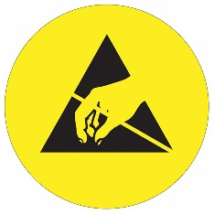

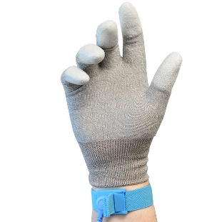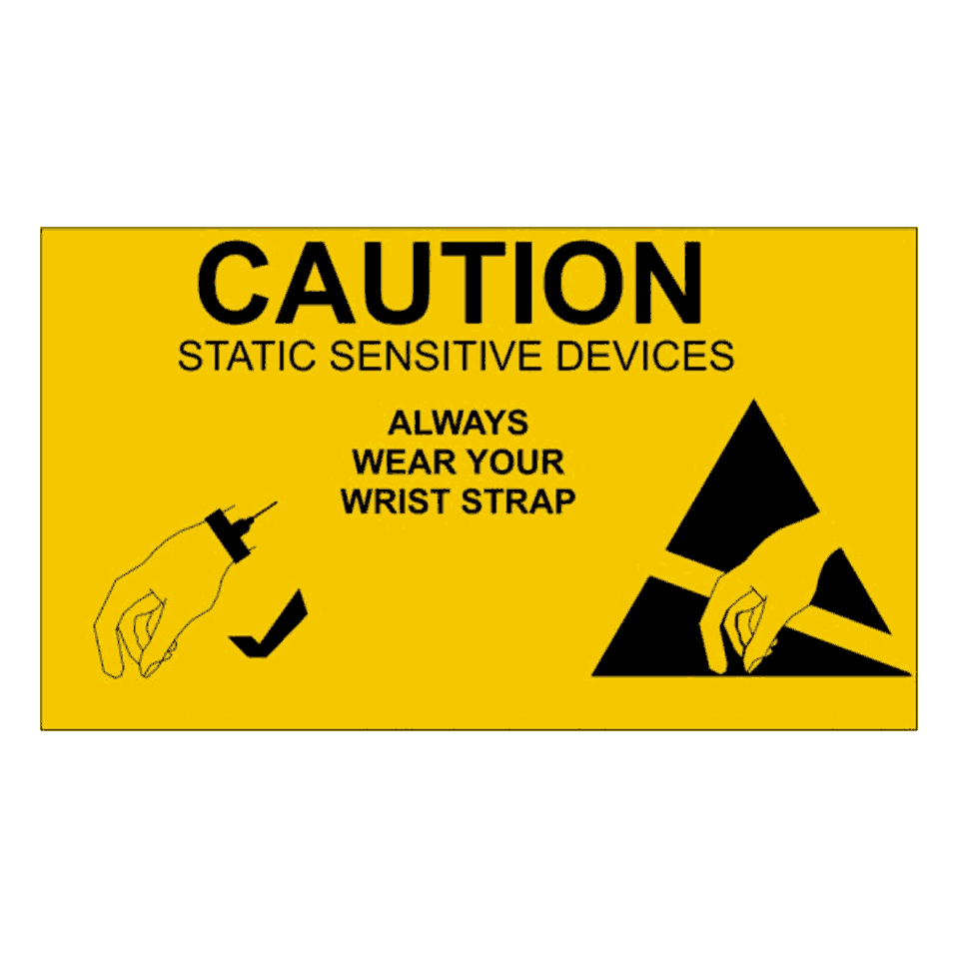
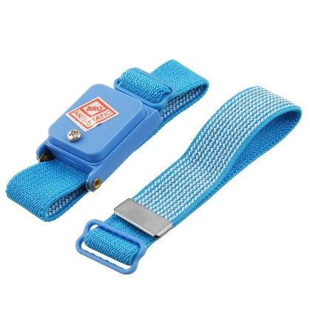



Follow 5S

- Sort
- Set in order
- Shine
- Standardize
- Sustain

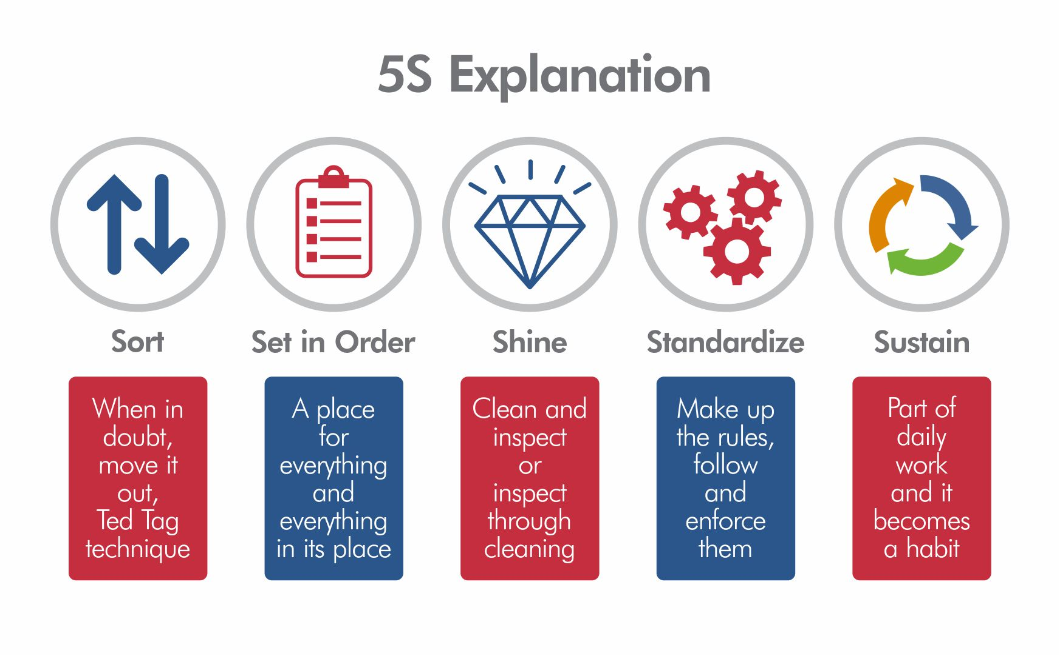

Components Identification and visual Inspection

Component List:

Gather all components and hardware that are mentioned in the bill of materials for Network Video Recorder as well as the required tools for assembly.

Visual Inspection:

Examine each component for any physical damage or defects. Address any issues before proceeding with assembly.

Steps for NVR Assembly

Fitment of all connectors

- Use Loctite (243) to tighten the connector.
- Place the NVR mechanical housing (13.86.8825) in a suitable workspace for assembly. (Refer figure no. 1)
- Insert the allied 3-Pin male power connector (01.01.10752) at the X1 port of the NVR mechanical housing and fix it with the help of 4 Nos PH M3x12 (01.01.10686) screw and M3 Nut. (01.01.10627) (Refer figure no. 1)
- Insert the M-12 D coded Female connectors (01.01.11048) at the X2 to X9 port and X10(J1 down side) and X11(J1 Upper side) Port of the NVR mechanical housing (13.86.8825) and tighten the respective lock nuts with the help of spanner. (Refer figure no. 1)
- Mount Sub D-9 Male connector (01.01.10993) at the X13 port on the NVR mechanical housing and tight it with the help of spanner. (Refer figure no. 1)
- Mount HDMI cable (01.01.10117) at the X12 port of the NVR mechanical housing and tighten 2 Nos CSK the screw (M3x10) along with washer(M3) and nut(M3) with the help of screw driver and hex spanner. (Refer figure no.1)
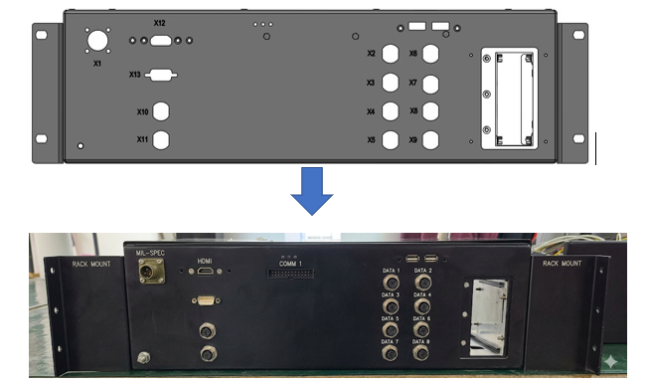
- Fix the USB port metal cover plate and HDMI Port Cover plate with the help of CSK M3x10 screw. Refer the following image.
Figure 1

Harness and Connectors

- Measure the required length (Refer table no. 1) of M-12 D coded Female connector’s (X2 to X9) cable and cut the cable size using a wire cutter.
- Insert the M-12 D coded connector’s wire in the 4-Pin Wago connectors (01.01.11072) with the help of aligners. For Wago connections please refer Table no. 2

Device Port | PCB Port | Length
X2 | J1 | 220 mm
X3 | J3 | 220 mm
X4 | J5 | 220 mm
X5 | J7 | 220 mm
X6 | J2 | 220 mm
X7 | J4 | 220 mm
X8 | J6 | 220 mm
X9 | J8 | 220mm

M12 D CODED CONNECTOR PIN | M12 D CODED WIRE COLOUR | WAGO CONNECTOR  PIN
1 | Yellow | 4
2 | White | 2
3 | Orange | 3
4 | Blue | 1

- Measure the required length (500mm) of M-12 D coded Female connector’s (X11 and X10) cable and cut the cable size using a wire cutter.
- Connect RJ45 connector with the help of crimping tool. For RJ45 Connection
- please refer table no.3

X11 TO RJ45 CONNECTION DETAILS
M12 D CODED CONNECTOR PIN | RJ 45 CONNECTOR | COLOUR
1 | 1 | YELLOW
2 | 3 | ORANGE
3 | 2 | WHITE
4 | 6 | BLUE

ASSEMBLY OF POWER SUPPLY BOARD (12/24)
- The first image shows 12V AC-DC SMPS converter.

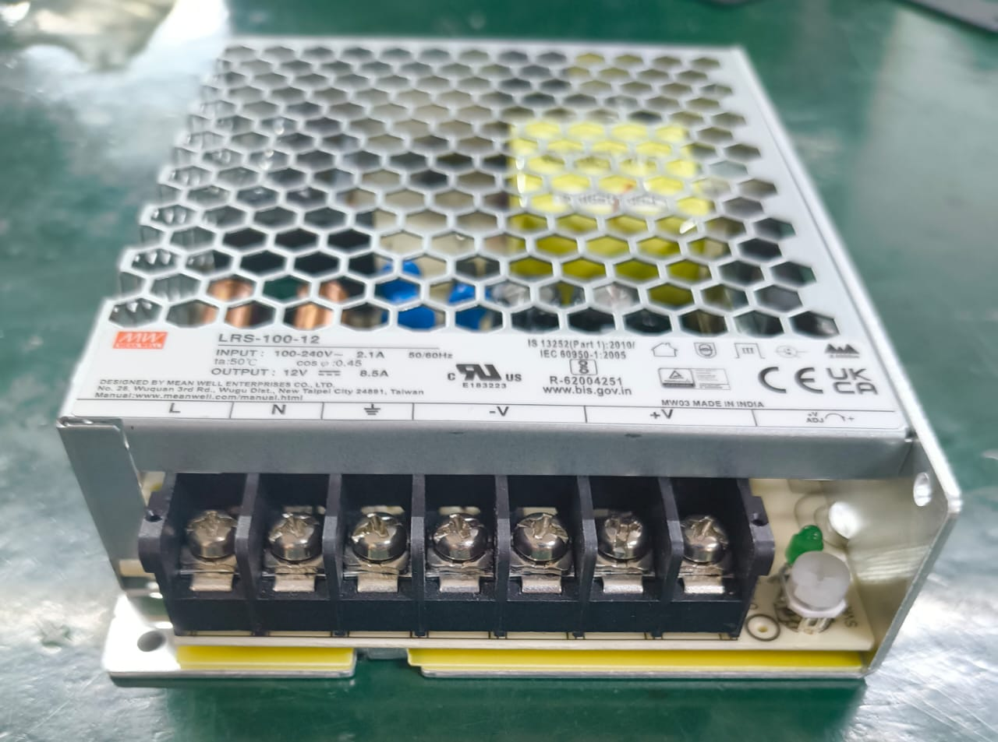
Figure 2

- Brass pillars are mounted the back side of the SMPS.
- The SPMS is attached to the heat sink using the brass pillars.

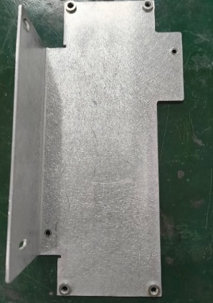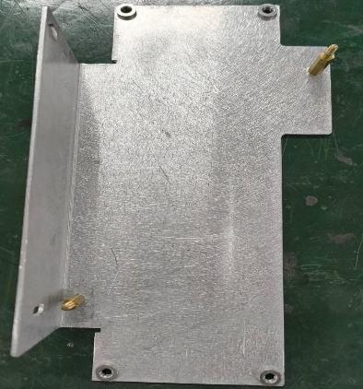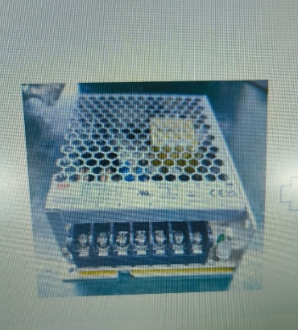

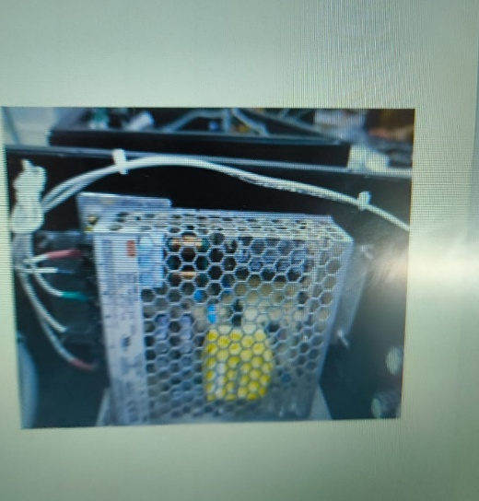
Figure 3

7.4 CADDY ASSEMBLY
- Mount the handle onto the handle-lock plate with the help of 2 nos screw(PH head M3x6) (in Red circle)
- Caddy lock set Part Number- 01.01.10707

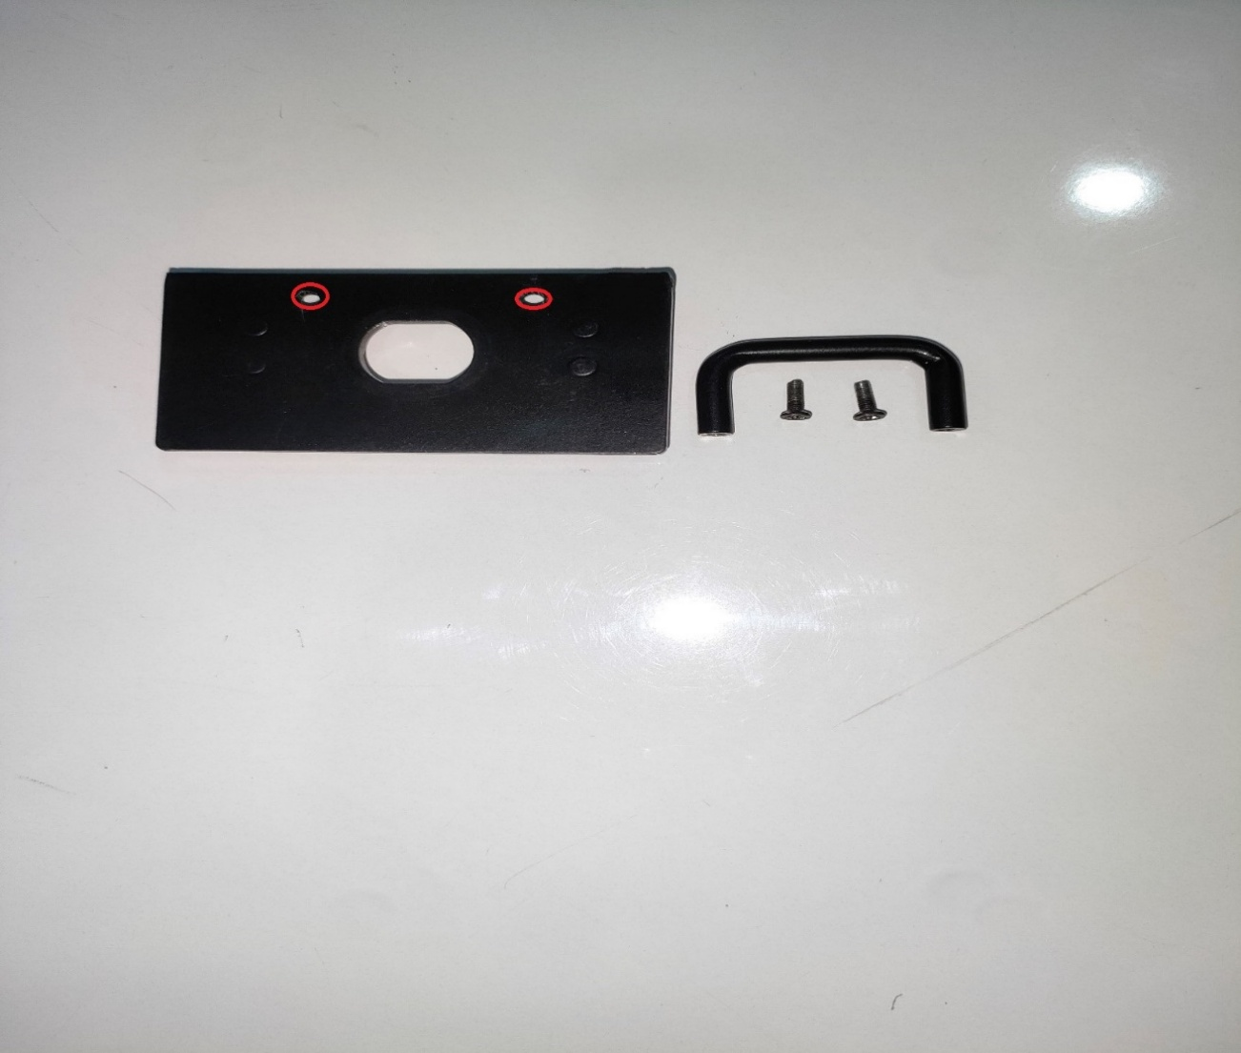

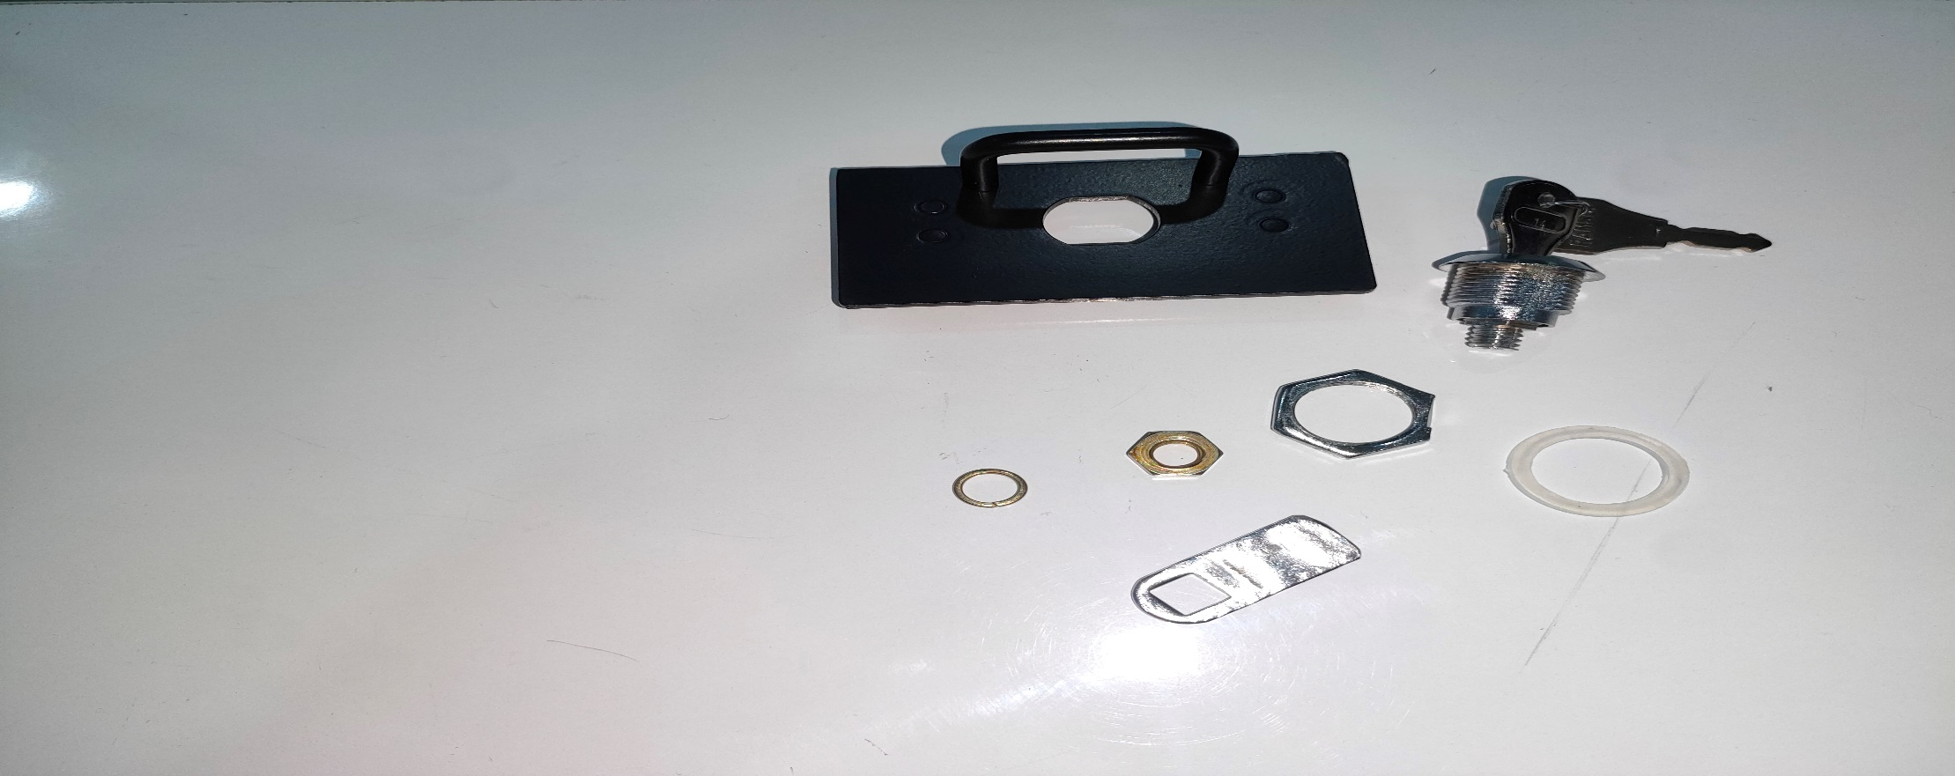
Figure 4
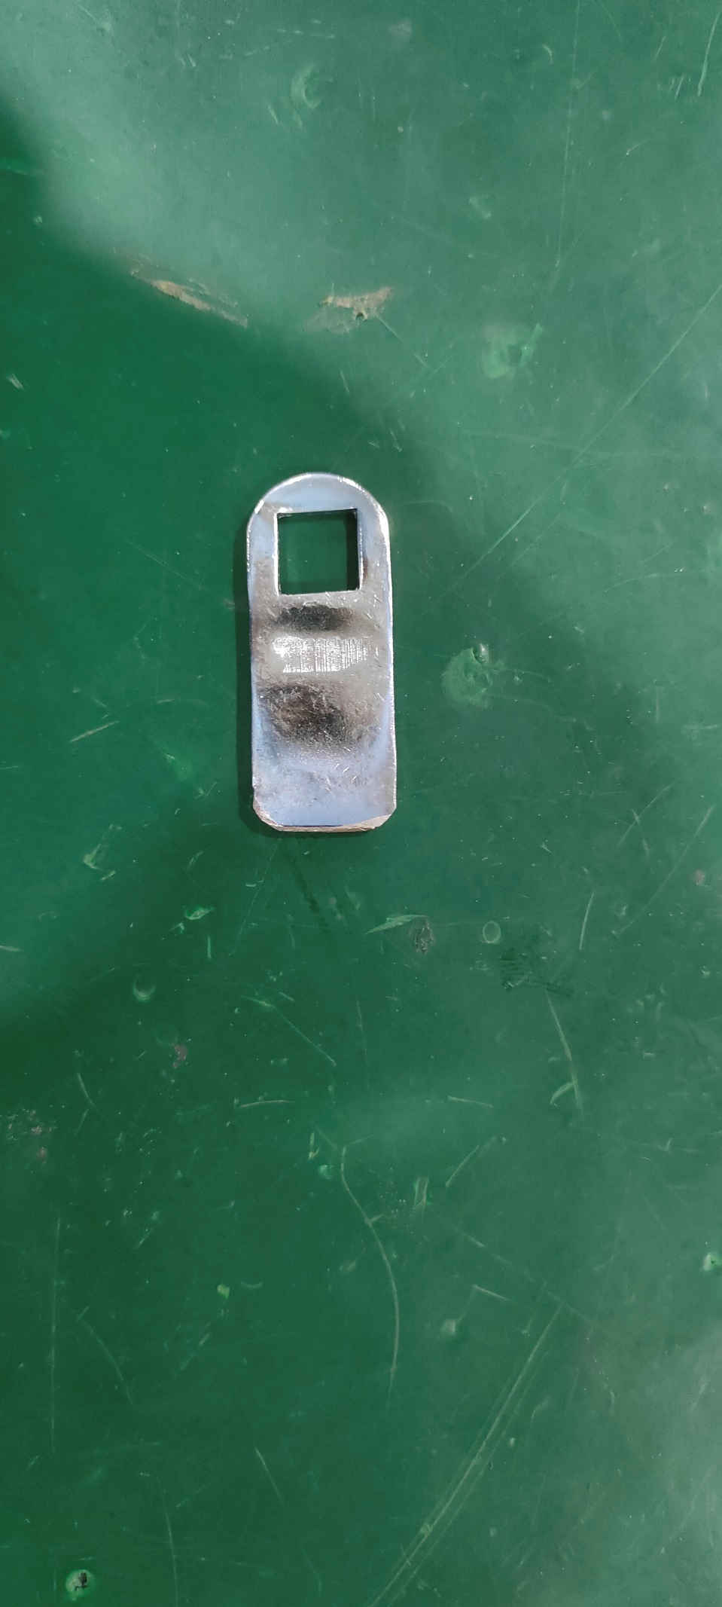
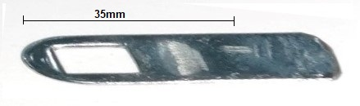
- Flat the cam lever and cut it off at 35 mm from the hole side of the same or if already Insert the lock body into its respective gasket.

Figure 5

- Insert the lock body into its respective gasket.
- Insert the lock body with gasket into the handle-lock plate hole from the handle side.

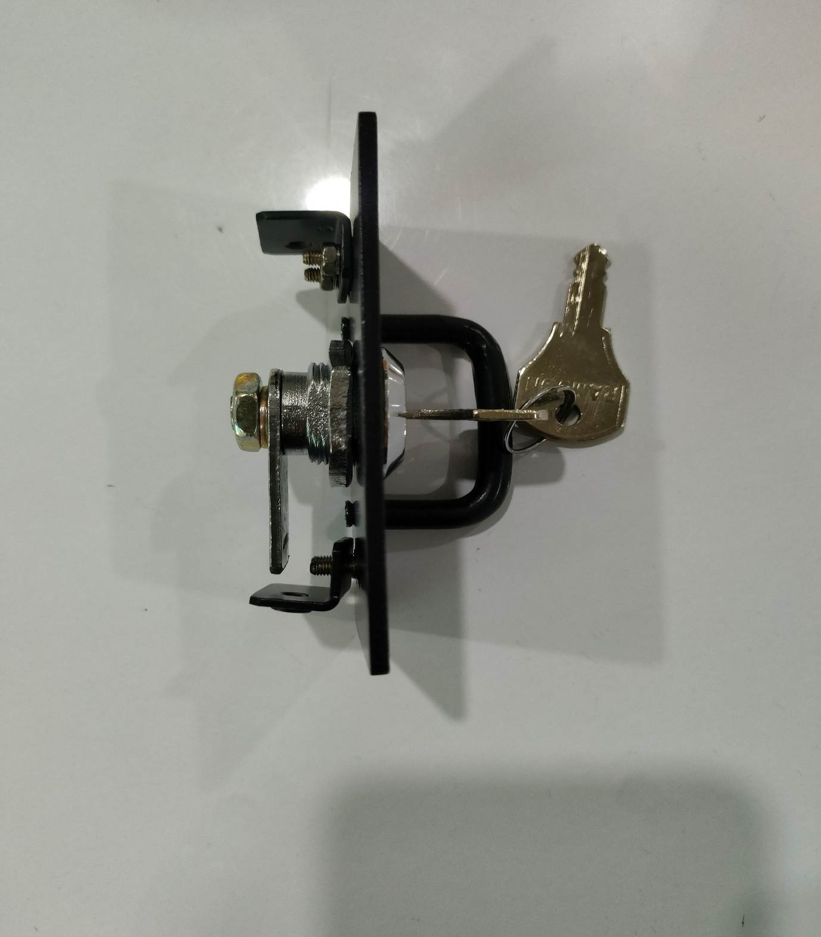
- Use one hand to hold the key lock mechanism in place to prevent it from turning while you tighten the lock nut.

Figure 6

- Test the lock operation several times to verify smooth functioning.
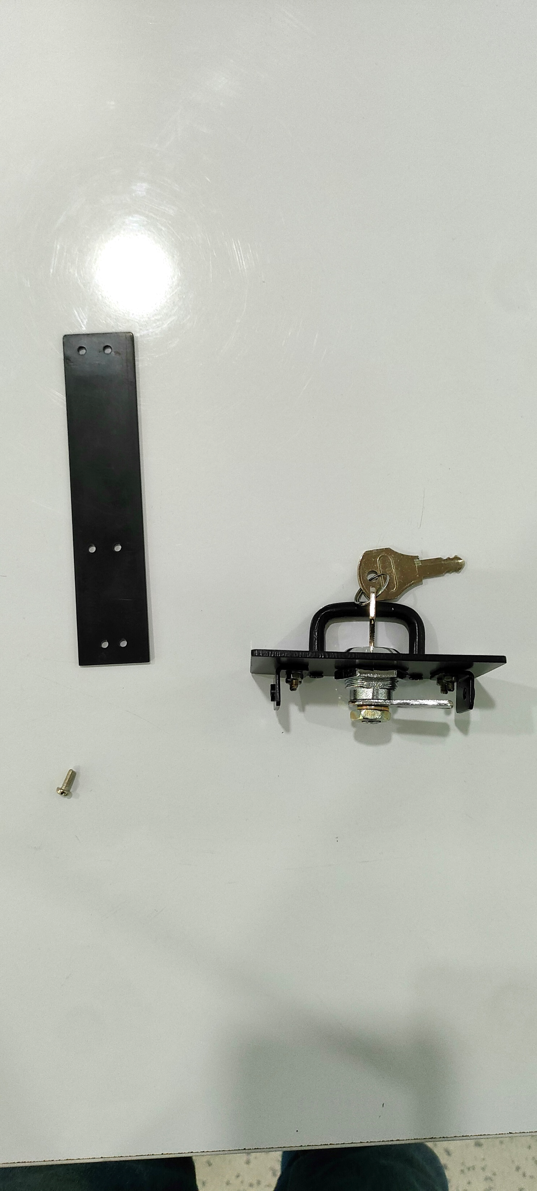
- Fit each L-Clamp with the help of 2 Nut(M3).
Figure 7

- Fix the Caddy sliding extrusion plate in that way where the lock plate and the middle hole of the caddy sliding extrusion plate length should be less comparison to the other side hole as per shown in the below image.
- Fix L-Clamp with Caddy sliding extrusion plate with the help of 2 Nos PH screw(M3x6), nut(M3) and washer.
- Fix the SSD (24.05.1180) with the help of screw (CSK M3x6) as per shown in the below image.
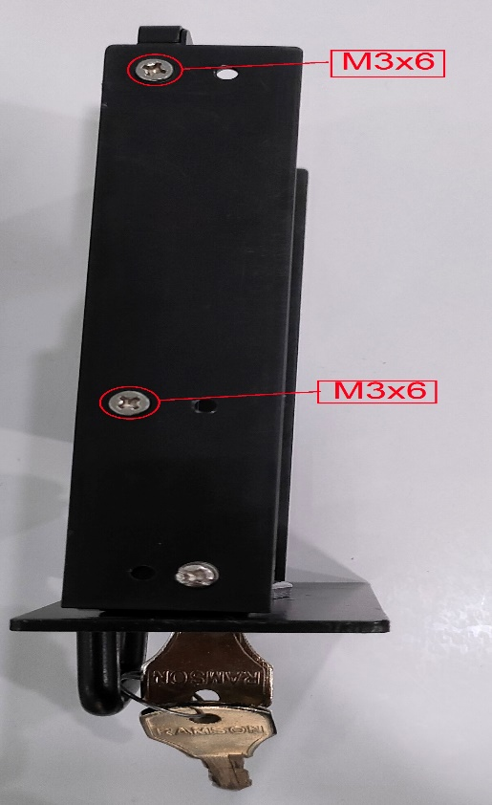
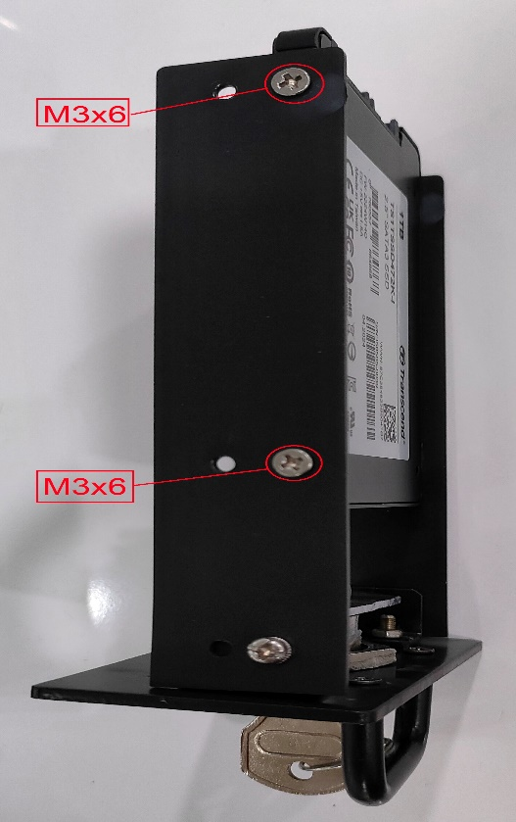

Figure 8
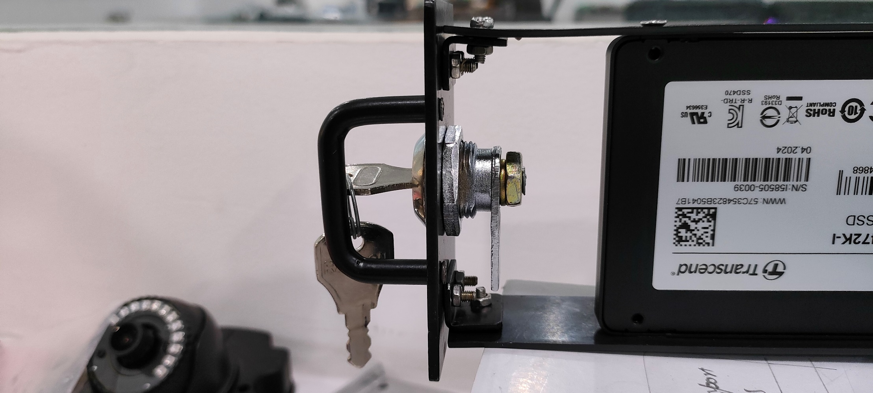

7.5 ASSEMBLY OF CADDY FRAME AND FITMENT

Figure 9
- Fix the 4-fiber slider with the help of Glue (NS810) and let it dry for 6 hours.
- Tight the four M3X15 brass pillars on Caddy frame.
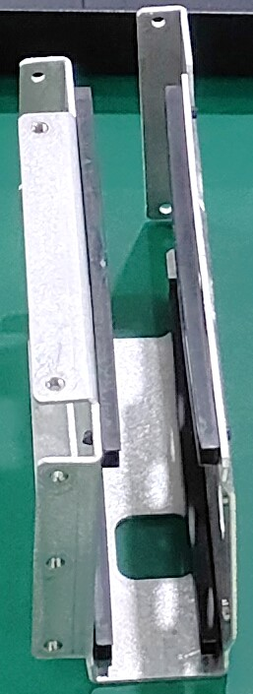
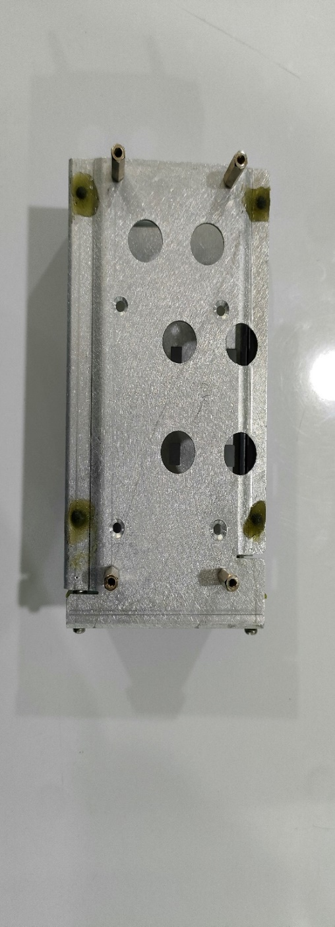
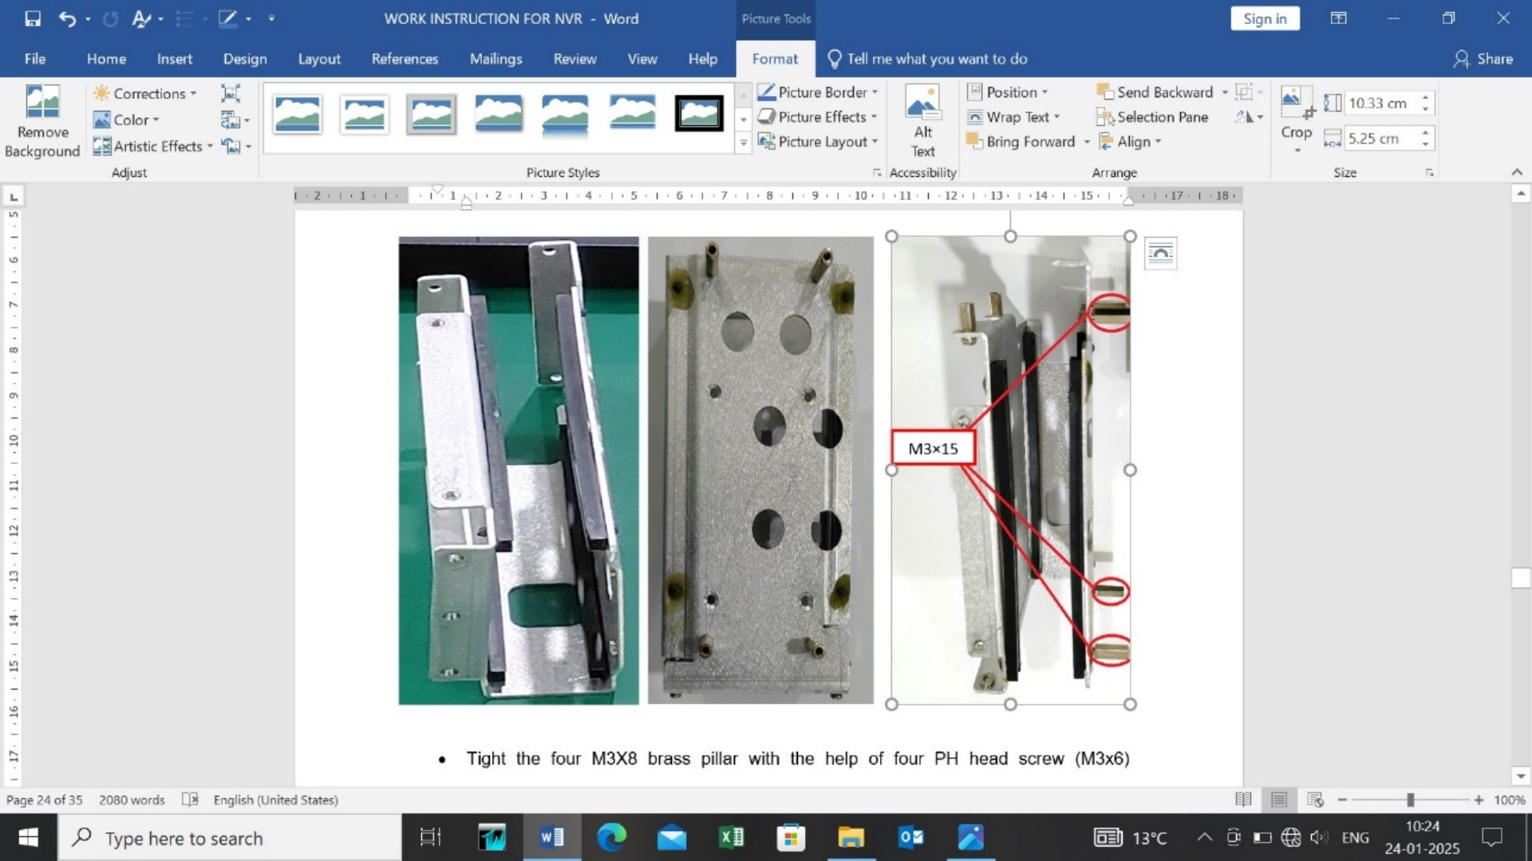

Figure 10

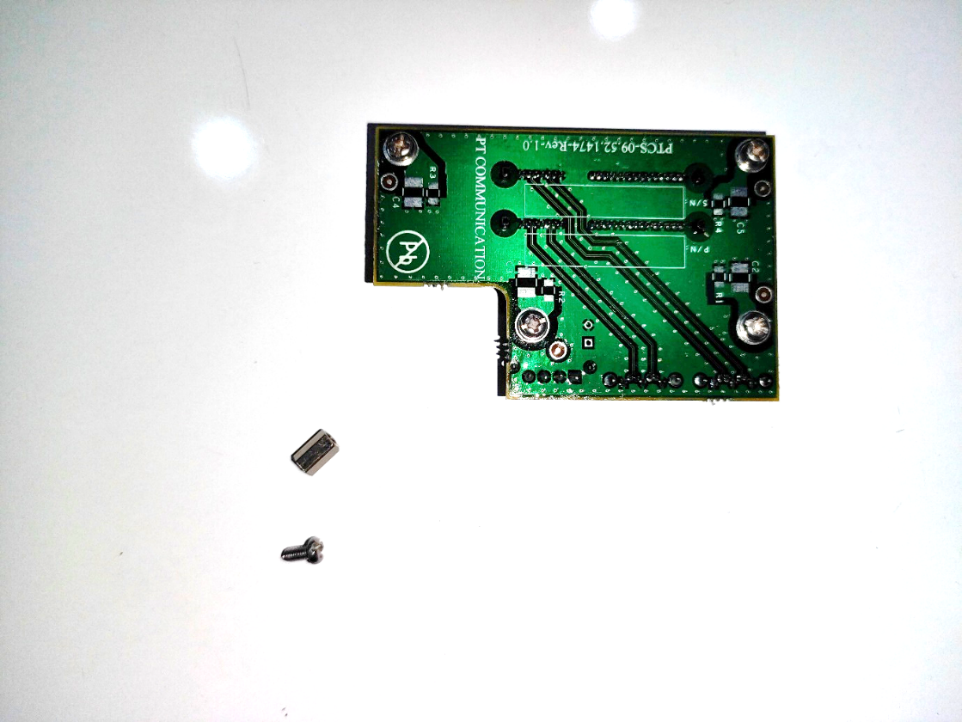
- Tight the 4 Nos M3X8 brass pillar with the help of four PH head screw (M3x6) (01.01.10626) and serrated washer(M3).
Figure 11

- Mount the PCB card (33.92.1474) on caddy frame with the help of 4 PH head screw (M3x6) (01.01.10626).
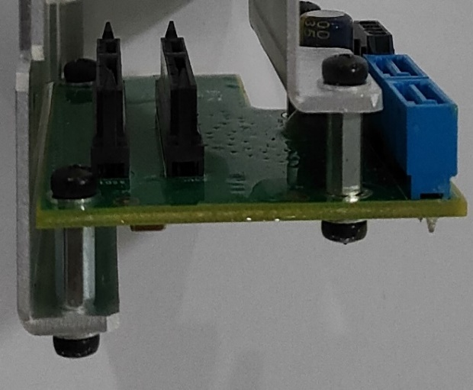
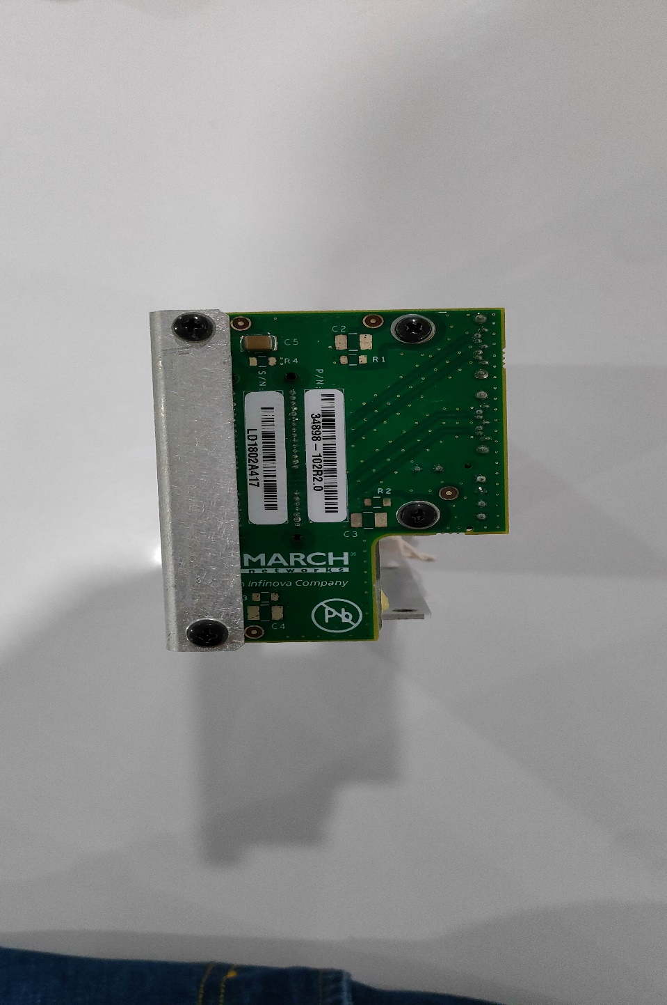

Figure 12

- Put the caddy frame on its designated place and fix it with the 4 CSK screw (M3x8) from the outer side of NVR.
- Tight 3 CSK screws (M3x8)(01.01.10645) from the front of NVR (Red Circle).
- Tight 2 PH (M3x10)(01.01.10648) screws to the bottom of NVR (Blue Circles).
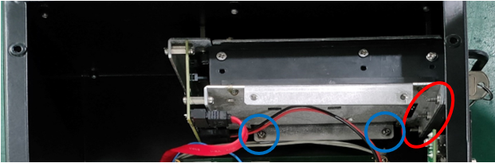

Figure 13

CABLES AND CONNECTORS

- Stick the sticker (22x67mm) on the NVR meachanical housing as shown below.
- Each connecting wire (+ve and -ve) length should be 140 mm Approx. which connects 12/24V power supply to (12/48V) power supply.
- At power supply(12/48V) board end, Each wire should have its repsective sleeve.
- For connection details refer below figure and table.
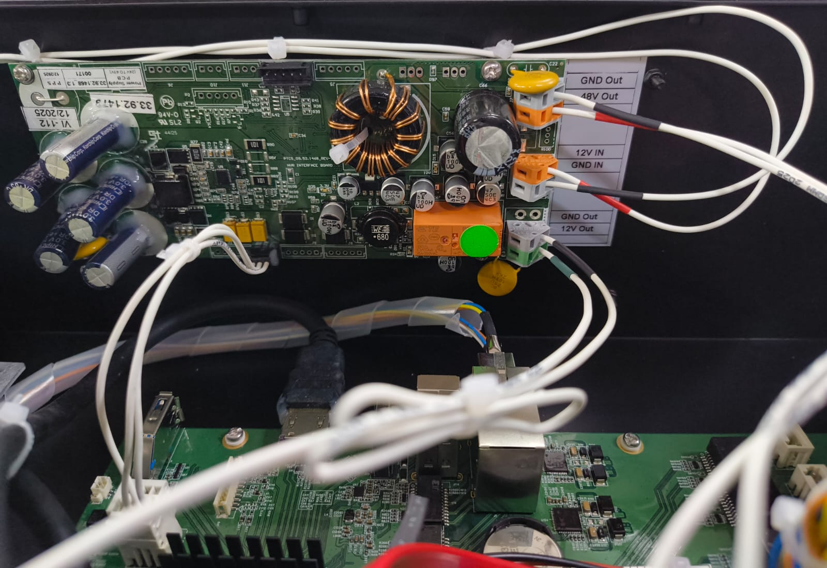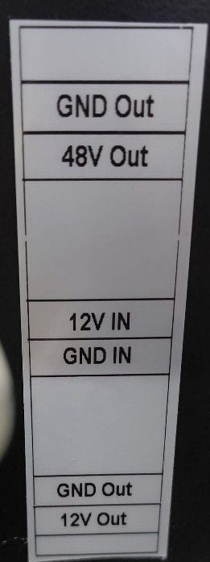
Figure 14
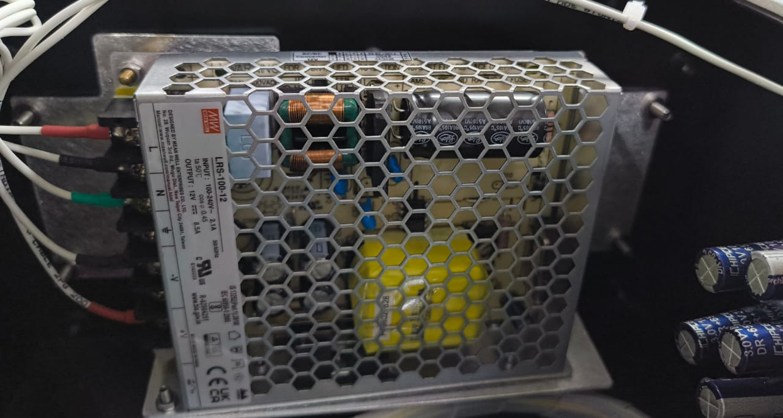
L – Line
N – Neutral terminal
Ground terminal
-V
+V

Figure 15

12/24 V Power Supply | 12/48VDC Power Supply
GND OUT | GND IN
24VDC OUT | 24VDC IN
12VDC OUT | 12VDC IN

12/48VDC Power Supply | NVR Main Board
GND OUT | 2Pin connector at Port No. JP21
48VDC OUT
GND OUT | 6 Pin connector at Port No. JP24
12VDC OUT
3 pin relimate connector at port no. J1 | 4 pin wago connector at port no. JP26

FITMENT

FITMENT OF SUPPLY BOARD (12/48) (33.92.1468) AND POWER SUPPLY (12/24) (33.92.1479)
- Place 2-piece thermal pad (09.06.0125) (15x25mm) to ensure proper conduction of heat through housing as shown below image.
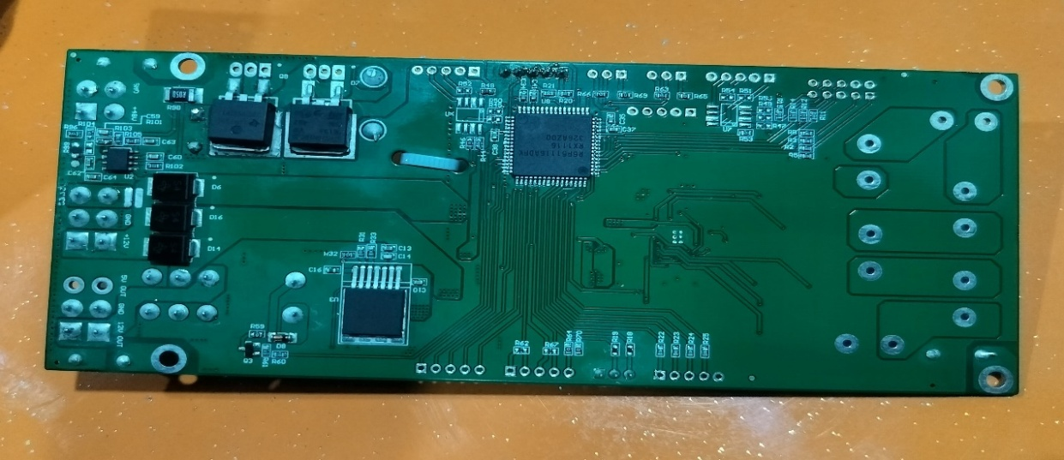
Figure 16

- Fix the power supply board (12/48 VDC) (33.92.1479) with the help of 4 PH head screw (M3x8) with serrated washer.
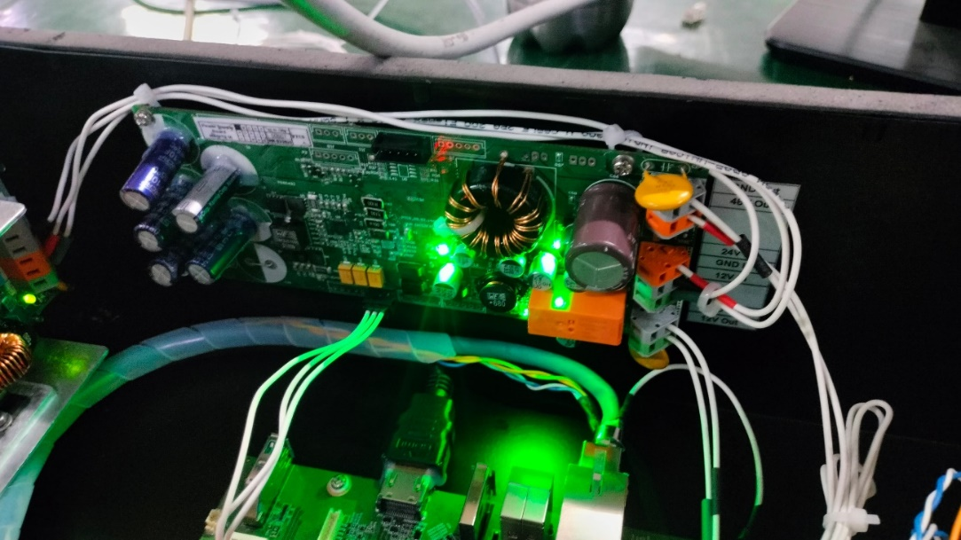

Figure 17

- Fix the 12/24 VDC power supply assembly with the help of 4 Nos. CSK M4×12 screws
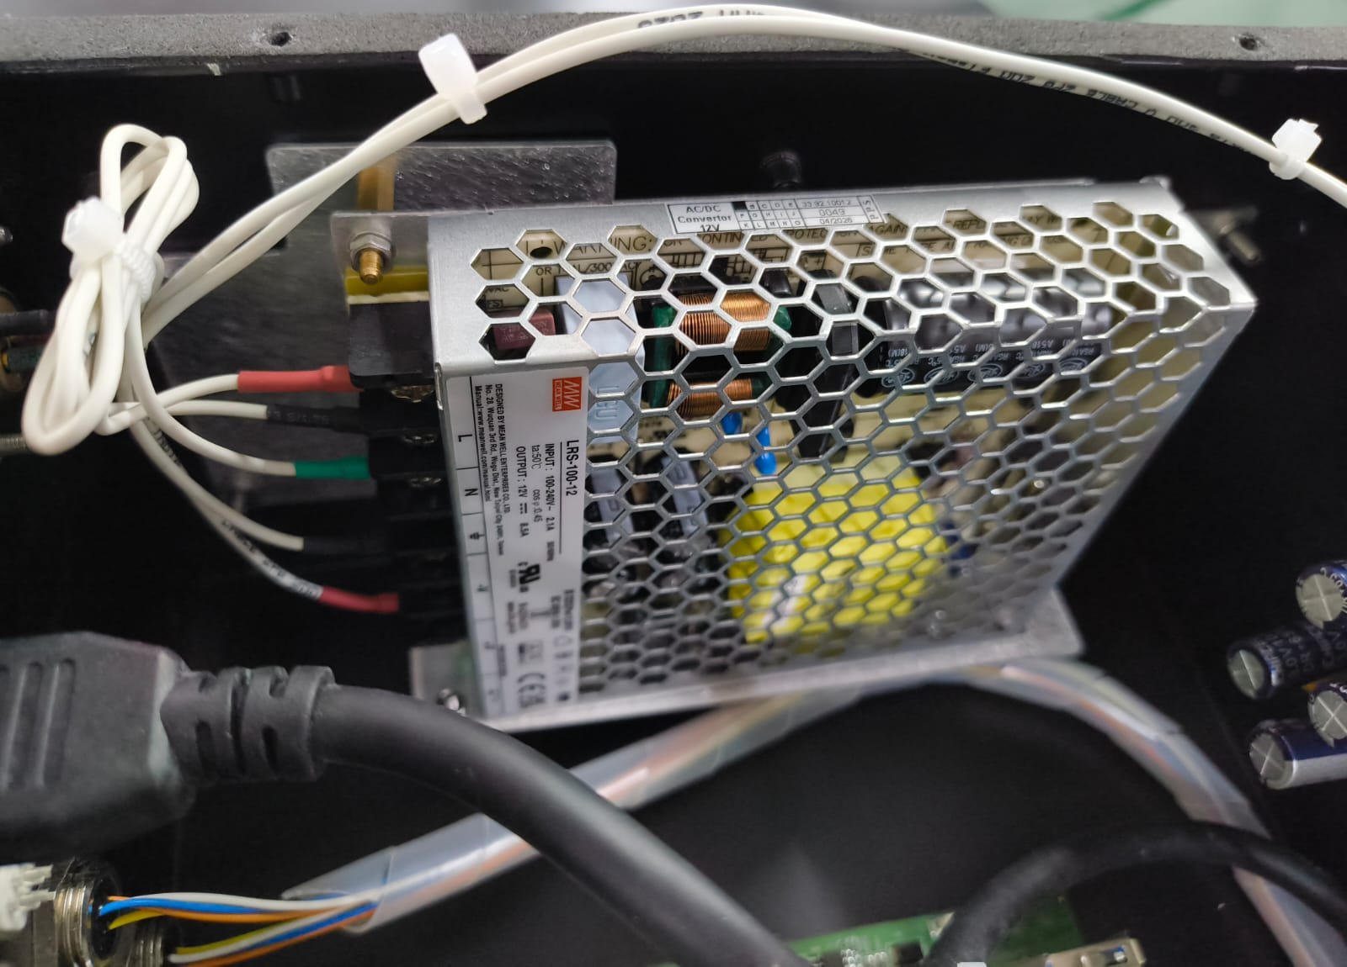

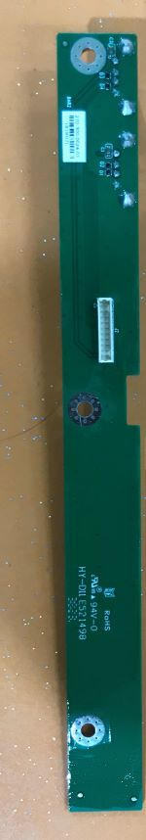

Figure 18

FITMENT OF LED BOARD

- Insert the light guide (3Nos.) at the NVR main housing and shrink the black sleeve on the middle one. Refer below image for further details.

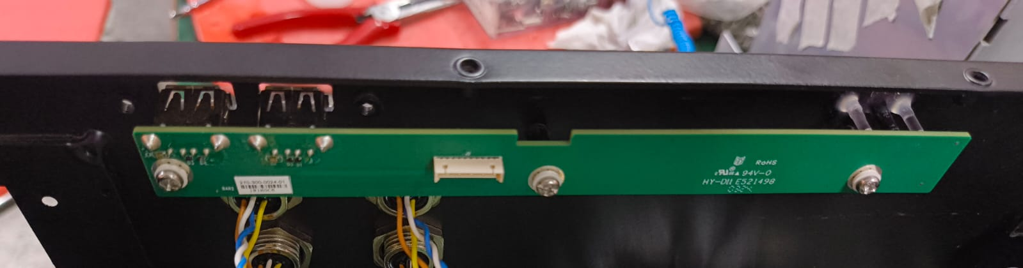

Figure 19

- Mount the LED Board on NVR with the use of 3 Nos PH head screw (M3x10) with the help of T-type nylon washer (M3) at both sides

FITMENT OF NVR BOARD

- Rub the portion of the Mechanical housing where the thermal pad will touch it to ensure the proper heat conduction via mechanical housing .
- Place Thermal pad (09.06.0125) (02 Nos- 2.8 mm thickness,20X40mm) & (140.0581.00) (01 Nos-1.8 mm thickness,20X40mm) and thermal pad (09.06.0125) (02 Nos- 2.8 mm THICKNESS, 20X20mm) & (01 Nos- 1.8 mm THICKNESS, 20X20mm) on the back side of main NVR PCB as shown below image.
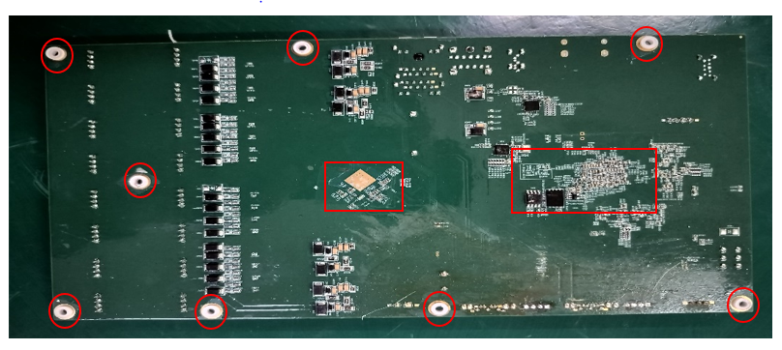
- Then fix the PCB with the help of 8 PH head screw (M3x8) (01.01.10645) and T- type nylon washer(26.94.0302) at both sides.
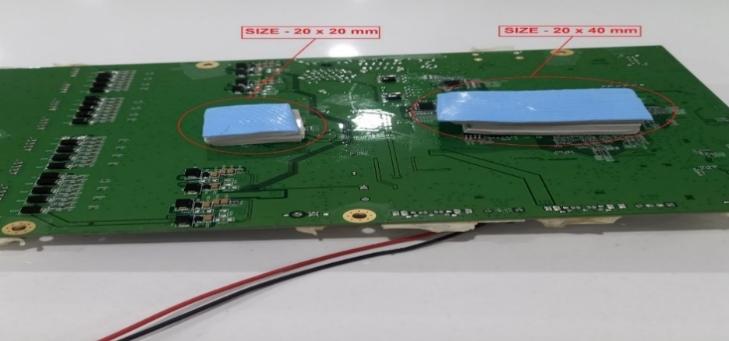

Figure 20

- Place the 3 volt battery(Cell) as shown in below picture.

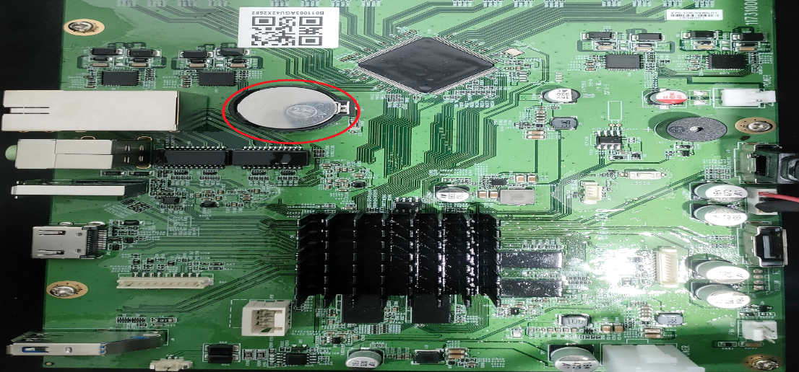

Figure 21

CONNECTION DETAILS

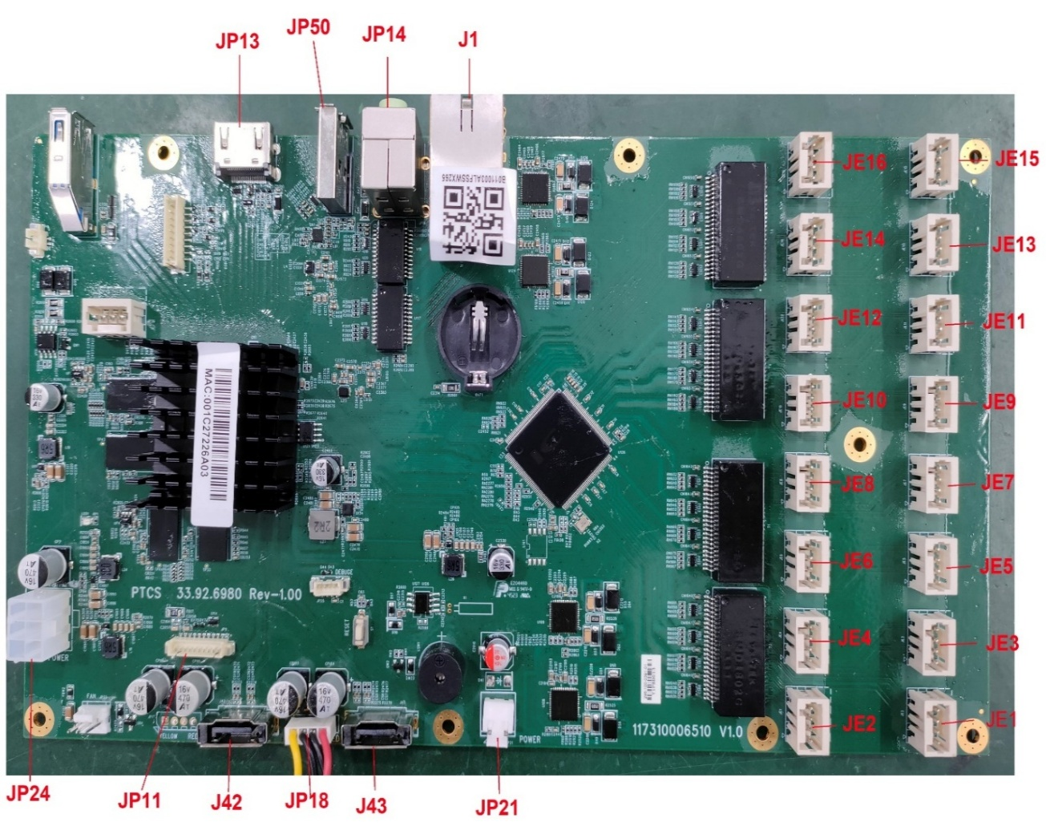
Figure 22

CONNECTION OF 3-Pin POWER CONNECTOR

POWER CONNECTOR | POWER SUPPLY INPUT
A | +VE
B | -VE
C | Shield with the screw of power connector with the help of lug

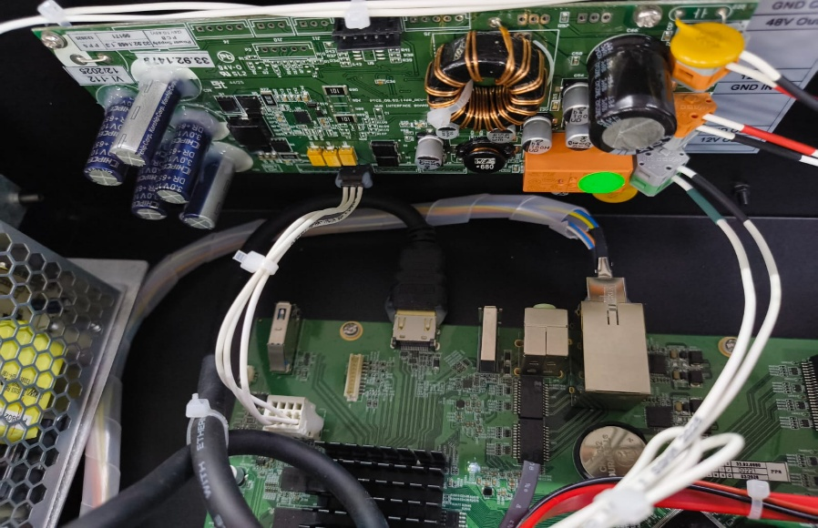
3 Pin Relimate Connector

Wago Connector

Figure 23

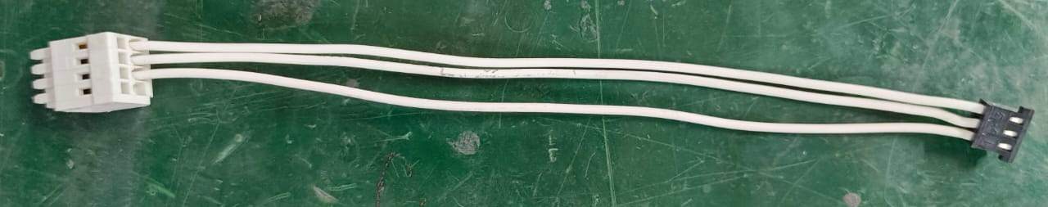
48 V Supply to main board communication cable
Figure 24

- Crimp the pins with three of approx. 200mm length of each.
- Insert pins in 3 relimate connector.
- Connect the other ends of relimate connector wire assembly to the pin wago connector.

RELIMATE CONNECTOR | WAGU CONNECTOR
 | Pin no.1
Pin no. 1 | Pin no.2
Pin no. 2 | Pin no.3
Pin no. 3 | Pin no.4

- Connect the FRC cable one end to JP11 port of NVR and other end to JP2 port of LED board.
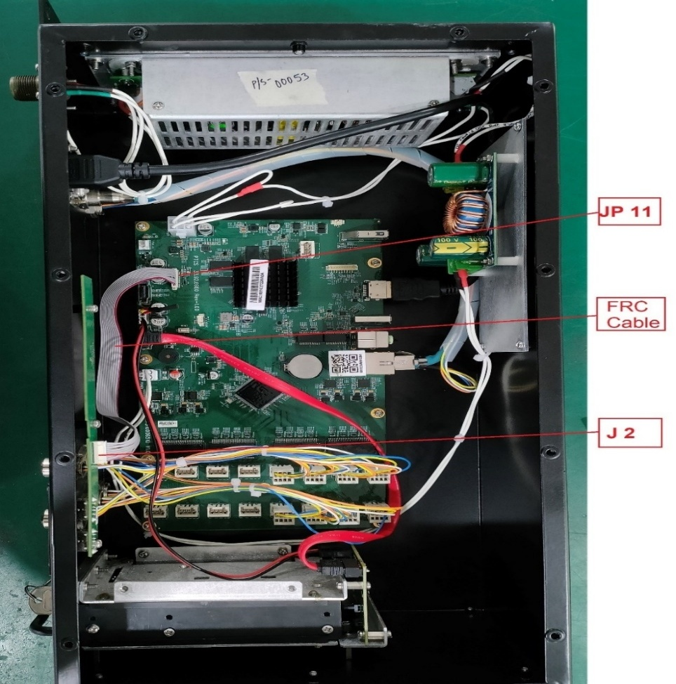
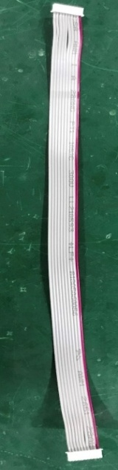
JP11

JP2

Length – 250 mm
Figure 25

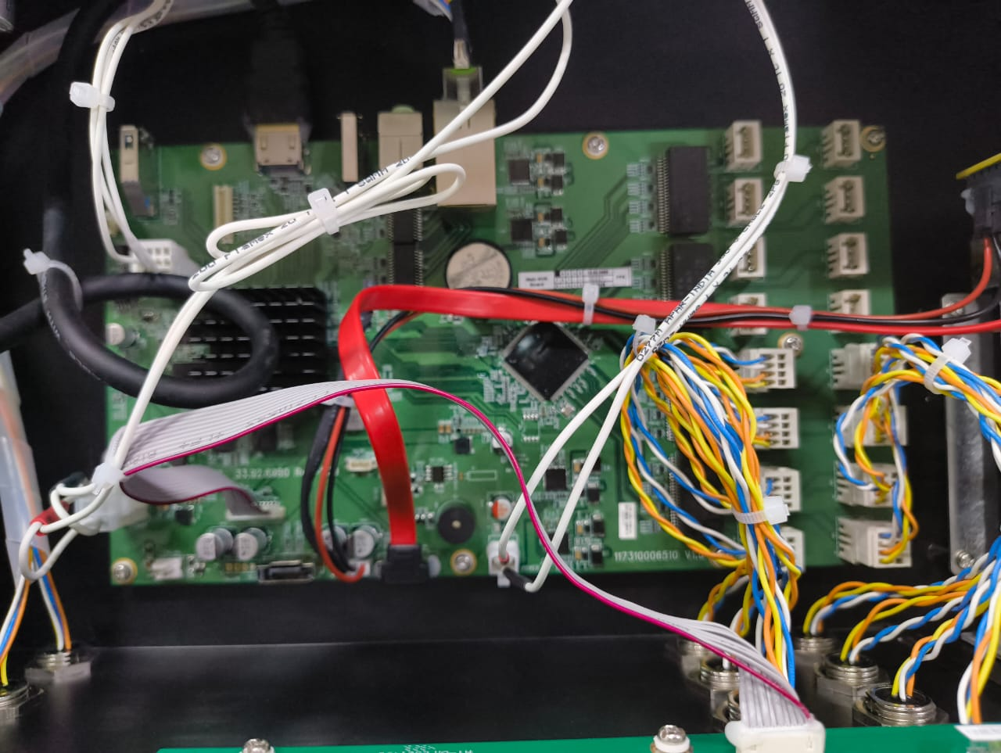
Figure 26

- Twist the M12 Connector wires in pairs of blue & white and yellow & orange.
- Connect all connectors to their port as per given picture below.

Device Port | PCB Port | Length
X2 | J1 | 220 mm
X3 | J3 | 220 mm
X4 | J5 | 220 mm
X5 | J7 | 220 mm
X6 | J2 | 220 mm
X7 | J4 | 220 mm
X8 | J6 | 220 mm
X9 | J8 | 220 mm

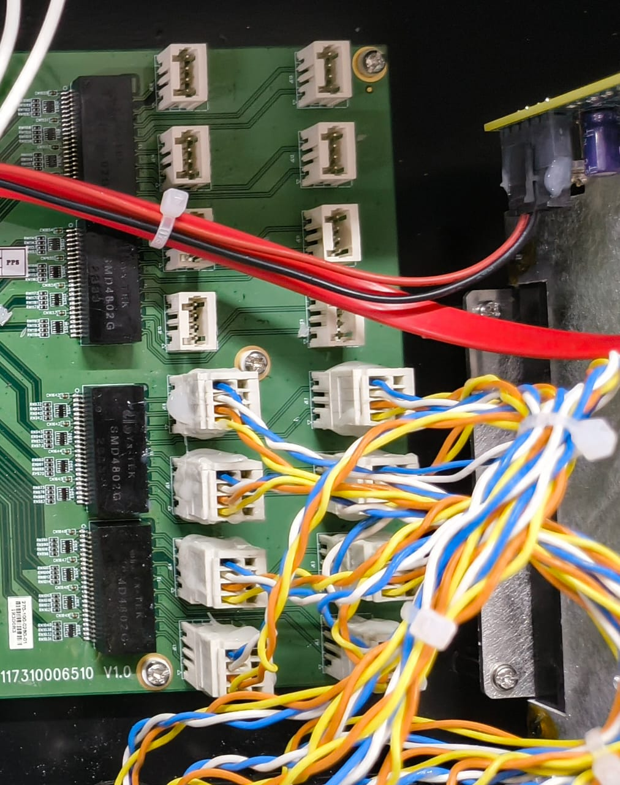

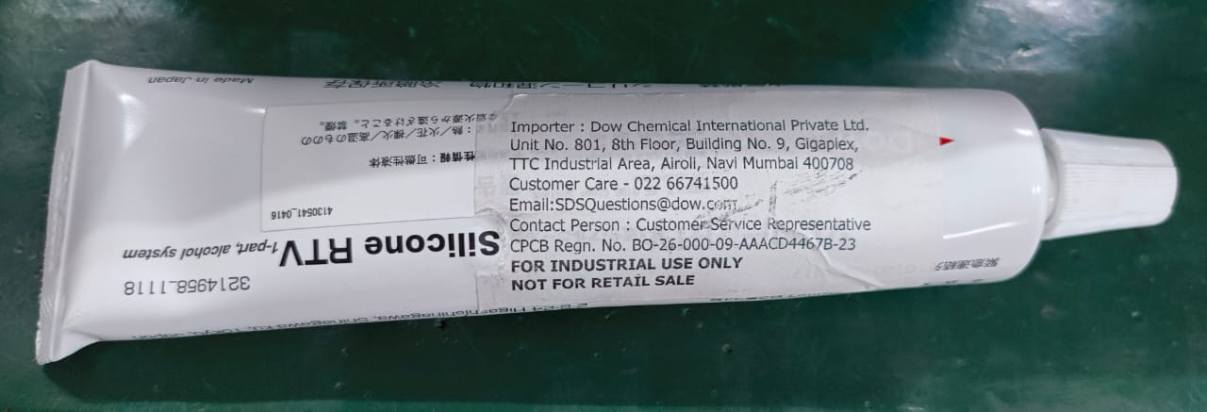
Figure 27

- Apply RTV silicone to all connectors to securely bond them so they remain fixed and do not move or loosen over time.
- Place the SSD assembly inside the caddy frame as per shown in below image.
SATA Board

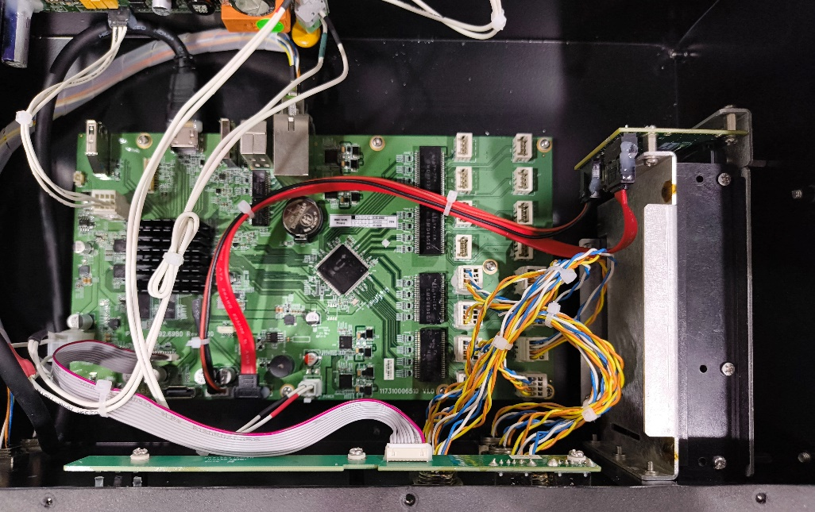
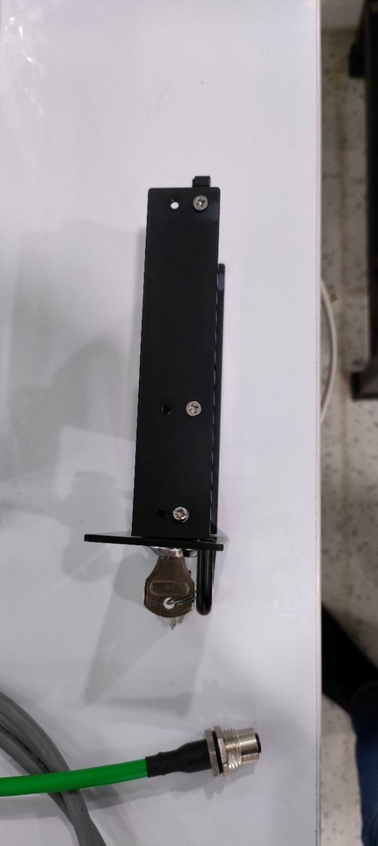
J18
J43
J1
J3

Figure 28

- J1 port of SATA Board is connected to J43 port of NVR Board through SATA cable.
- J3 port of the SATA Board is connected to J18 on the NVR through a power cable.

- The Caddy is mounted inside the device.

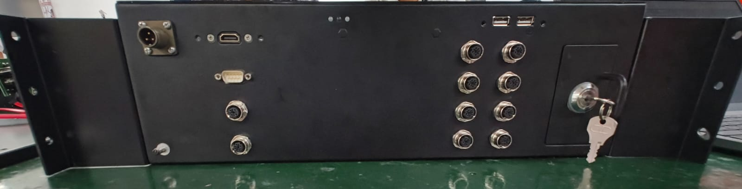
Figure 29

FINAL ASSEMBLY UNIT

- Mount the left and right NVR housing side plate with the help of CSK screw (M4x12) (01.01.10686) as shown by red circle. Make sure the left side plate gets fitted on left and the right sided gets fitted on the right side of NVR.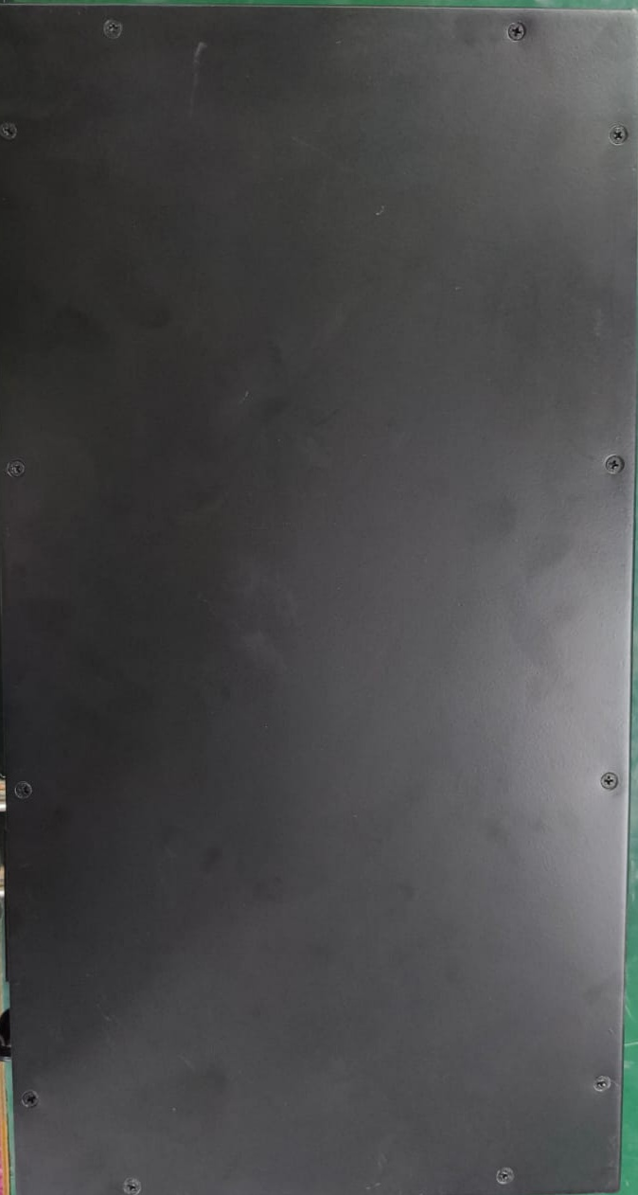
Figure 30

- Put the gasket on the upper side of NVR and place the upper cover and tight with the screw (CSK M3x10) (01.01.10648).

***** END OF DOCUMENT*****

